OFISA
Modernization GEFI
Report Basic Analysis

Trivadis AG

Perry Pakull
Principal Consultant

perry.pakull@trivadis.com
+41 79 264 88 37

Document Version 1.0
©2014 Trivadis AG

Document Information
Document | OFISA Modernization GEFI Report Basic Analysis
Document Class | Confidential
Author | Perry Pakull
Status | Work in Progress
Last Change | 19.02.2014
Document Name | OFISA GEFI Basic Analysis.docx

Change History
Version | Who | Date | Comment
0.5 | Perry Pakull | 05.02.2014 | Initial Version including results from questionnaire and analysis report
0.6 | Perry Pakull | 11.02.2014 | Complexity results and License information added
1.0 | Perry Pakull | 18.02.2014 | Final estimations added

Table of Contents
Document Information 2
Change History 2
Table of Contents 3
Table of Figures 6
1 Introduction 7
1.1 Motivation 7
1.2 Goals 7
2 Workshop Results 8
2.1 Customer Information 8
2.2 Application Development 8
2.2.1 General information 8
2.2.2 Oracle products used in the application 8
2.2.3 Other software products used in the application 8
2.2.4 Technical documentation 8
2.2.5 Number of application modules 9
2.2.6 Software engineering environment 9
2.2.7 Business process for the application 9
2.2.8 Development Guidelines 9
2.3 Modernization Intention 10
2.3.1 What are the reasons for the modernization intention? 10
2.3.2 Understanding of the modernization intention 10
2.4 Modernization Planning 10
2.4.1 Modernization Timelines and Budget 10
2.4.2 Modernization Timelines 10
2.4.3 Modernization Strategy 10
2.4.4 Modernization Rollout 10
2.4.5 New Requirements 11
2.4.6 Dependencies to other Systems 11
2.5 Target Platform 11
2.5.1 Technology of the target platform 11
2.5.2 Operating System for the target platform 11
2.5.3 Reasons for the selected technology and target platform 11
2.5.4 Resources available for the selected technology and target platform 11
2.5.5 Training needed 11
2.6 General technical Information 12
2.6.1 Integration with local hardware 12
2.6.2 Infrastructure of Client Computer 12
2.6.3 Infrastructure of Servers 12
2.6.4 Infrastructure of Development Computers 12
2.6.5 Database Version 12
2.6.6 Application Server Version 13
2.7 Technical information Oracle Forms 13
2.7.1 Forms Version 13
2.7.2 Icons 13
2.7.3 Color Palettes 13
2.7.4 Coordinate System 13
2.7.5 Window and Canvas Sizing 13
2.7.6 Menu Control 13
2.7.7 Access of Client File System 13
2.7.8 Integration with Microsoft Products 14
2.7.9 PL/SQL Libraries 14
2.7.10 Data Blocks DML Data Target Type 14
2.7.11 Business Logic 14
2.7.12 Multi Language Support 14
2.8 Technical information Oracle Reports 14
2.8.1 Version 14
2.8.2 Reports calling method 14
2.8.3 Reports Format 14
2.8.4 Data Sources 15
2.8.5 Fonts 15
2.8.6 Print Preview 15
2.8.7 Output Formats 15
2.8.8 Libraries and Images 15
2.8.9 SRW Package 15
3 Technical Analysis 16
3.1 Approach to determine the technical Complexity 16
3.2 Assessment of the technical Complexity 16
3.3 Complexity of the Application GEFI 17
3.3.1 Entire Application Complexity 17
3.3.2 Application Complexity Distribution 18
3.3.3 Application Complexity Code Documentation 18
3.3.4 Application Complexity Database Access 18
3.3.5 Application Complexity Data Blocks 19
3.3.6 Application Complexity Criteria and Weighting 19
3.4 Forms Upgrade Issues 20
3.4.1 Obsolete Built-Ins 20
3.4.2 Obsolete Triggers 20
3.4.3 Triggers with Restricted Usage 20
3.4.4 Obsolete Item Types 20
3.5 Analysis Report 21
3.6 Removed Components 21
3.6.1 Oracle Terminal 21
4 Effort Estimation 22
4.1 Correction of Upgrade Issues 22
5 Infrastructure 23
5.1 Intranet Architecture 23
5.2 High Availability 23
5.3 Forms Server Architecture 24
5.4 Server Configuration 24
5.5 Memory Estimation 24
5.6 Network Bandwidth 25
6 Licensing 26
6.1 Contact 26
6.2 Development Environment Licenses 26
6.3 Test Environment Licenses 26
6.4 Production Environment Licenses 26
6.4.1 Named User Plus License Conditions 27
6.4.2 Processor License Conditions 27
6.5 Example Calculation 27
6.5.1 Application Server Production Environment 27
6.5.2 Development 27
6.6 Additional Notes 27
7 Next Steps 29
8 Addendum 30
8.1 Short Terms 30
8.2 Oracle Documents and References 30

Table of Figures
Figure 1 Application Complexity 17
Figure 2 Application Complexity Distribution 18
Figure 3 Application Complexity Code Documentation 18
Figure 4 Overall Application Complexity 18
Figure 5 Application Data Blocks 19
Figure 6 Application Complexity Criteria and Weighting 19
Figure 7 Simple Intranet Architecture 23
Figure 8 Forms 11g Architecture and technical Components 24

Introduction
This document summarizes the results and recommendations of the Forms Basic Analysis workshop on the OFISA Forms 6i application GEFI. The workshop has been performed at OFISA Informatique SA on 04.02.2014 and 05.02.2014.

Motivation
The application GEFI is based on Forms and Reports 6i and used by 80 customers. OFISA wants to finalize the support for this version until 2018. In order to keep the customers OFISA needs to support their technical requirements.
The overall modernization strategy has been made by OFISA before this workshop. OFISA already created an alternative application based on Microsoft technologies. Some customers should migrate from the Forms and Reports based GEFI application to the new Microsoft based application. For the remaining customers an upgraded version based on the actual Forms and Reports version should be built.

Goals
The goals of the Forms Basic Analysis workshop are:
- find existing upgrade issues in the application
- estimate the development effort for the upgrade
- define a basic infrastructure setup for the new version
- estimate upcoming license costs

Workshop Results

Customer Information
Name | OFISA Informatique SA
Contact (Name) | Stefan Mittermayr
Contact (Level) | Responsable opérationnel
Date | 04.-05.02.2014
Reason | Forms Basic Analysis

Application Development

General information
Name of the application | GEFI
Function of the application | Financial Accounting  Public Accounting  Estate Accounting  Township Accounting
When does the development start? | 1988 (SQL*Forms 2)
Is the application business critical? | Yes (for the customers of OFISA)
Number of registered users | < 100
Number of concurrent users | < 100
Which user groups/stakeholders exist? | Financial Accounting  Public Accounting  Estate Accounting  Township Accounting
Is documentation available? | Online User´s Guide (HTML)
The GEFI application is a product which is developed and distributed by OFISA.

Oracle products used in the application
- Oracle Database Standard Edition
- Oracle Forms
- Oracle Reports

Other software products used in the application
- Microsoft Office Word, Excel
- Microsoft Visual Basic

Technical documentation
Does an actual technical documentation exist? | No
Does an actual user´s guide exist? | Yes
Does the application provide a help function? | Yes

Number of application modules
Forms modules (FMB) | 511
PL/SQL Libraries (PLL) | 40
Object Libraries (OLB) | 8
Menu modules (MMB) | 4
Reports modules (RDF) | 277
Graphics modules (OGD) | 0
Windows Libraries (DLL) | 20
Icons (ICO) | 104
Images with different formats | 225
Visual Basic Files (EXE) | 2
Help HTML Files | many
Windows Registry Files (REG) | 6
Resource Files (RES) | 286

Software engineering environment
Which environments and systems are used for the application?
Which environments exist? | Development, Test
Is the build and deployment process defined? | Yes
How is the responsibility organized? | One person
Is version control used? | No
Is there a change management system for issue tracking? | No

Business process for the application
Is there a business process in the application? | No
Should the modernization project create a business process? | No

Development Guidelines
Design/Architecture | Yes
Law | No
Data privacy | No
Usability | No
Ergonomics | No
Coding guidelines | Yes
Established process for guidelines | Templates for Forms and report modules

Modernization Intention

What are the reasons for the modernization intention?
Technical reasons | Yes
New requirements | No
Availability of resources | No
Political reasons | No
Missing Oracle support | No
Other reasons | OFISA wants to finalize the support for this version of the application

Understanding of the modernization intention
What is the developer´s opinion about this project? | No major change for the developers. Forms, Reports, SQL and PL/SQL development remains unchanged.  New infrastructure based on application server is the challenge.
What is the customer´s opinion about this project?

Modernization Planning

Modernization Timelines and Budget
Is a detailed analysis of the migration effort needed? | Yes
Is a budget for the modernization costs available? | No
Are there timelines for the modernization? | Yes

Modernization Timelines
- Start the modernization in 2014 with a technical analysis to find out the upgrade issues and the needed effort for the new version
- Support for the existing Forms 6i solution should end in 2018

Modernization Strategy
- OFISA supports 80 customers using the application today
- Alternative solution covering Township Accounting and Public Accounting based on SQL Server and Microsoft .NET technologies is available
- Switch 60 customers to the new application based on Microsoft technologies
- Create an upgraded version based on the actual Oracle Forms and Reports software without functional changes (technical 1:1 upgrade)
- Switch 20 customers to the new Oracle version
- OFISA itself needs parallel development

Modernization Rollout
- Customers get the complete new version
- Customers should be able to run the old 6i version and the new 11g version using a single source of data

New Requirements
- Support for QR Codes is needed

Dependencies to other Systems
- Document Management System based on Lotus Notes, interface implemented with Visual Basic
- Export and Import of plain text data using TEXT_IO

Target Platform

Technology of the target platform
Same technology for all applications | Yes
Actual Forms/Reports version | Yes
Integration with other technologies | No
Oracle ADF | No
Open Source Java (WebUI/RIA, RichClient) | No
Microsoft .NET (WebUI/RIA, RichClient) | No

Operating System for the target platform
Operating System Client | Windows XP, Windows 7 64
Operating System Application Server | Windows Server
Operating System Database | Windows Server
Is this certified? | Yes

Reasons for the selected technology and target platform
- Know-how of employees

Resources available for the selected technology and target platform
Developer | 10-15
Database Administrator | 1-2
Application Server Administrator | 0
Infrastructure and Hardware Administrator | 4-5

Training needed
Development | No
Administration | Yes

General technical Information

Integration with local hardware
Printer | No
Barcode Scanner | ?
Special Fonts | No
Other technical equipment | No

Infrastructure of Client Computer
- Each customer has its own infrastructure
- OFISA does not force or restrict their customers to use a specified infrastructure or specified software versions for the client computers

Infrastructure of Servers
- Each customer has its own infrastructure
- OFISA does not force or restrict their customers to use a specified infrastructure or specified software versions for the servers

Infrastructure of Development Computers
CPU
Memory
Forms/Reports Builder installed | Yes
Graphics installed
Designer installed | No
SQL and PL/SQL Tools installed
Other Software used for development
Upgrade possible?
Privileges of developers

Database Version
Version | 11g R2
Edition | Standard
Migration of database involved? | No
Certified for the new infrastructure? | Yes
Which constraints exist if a migration is needed?
Special options (RAC) | No
CPU and Memory resources | Small to Medium
Operating System | Windows
Other Systems on the database server | No information

Application Server Version
Not used for Forms and Reports 6i.

Technical information Oracle Forms

Forms Version
- Forms 6i

Icons
Individual Icons and Images used | Yes
Format of Icons | ICO
Format of Images | BMP, JPG, GIF, TIFF

Color Palettes
Are color palettes used for Forms Modules | No
Does a template exist for color palettes | No

Coordinate System
Used coordinate system | Real
Unit | Centimeter
Change needed | No

Window and Canvas Sizing
Size of Canvas | 20,875 x 11,838
Does the application use the complete display size? | No

Menu Control
Is Forms Menu Security used | No
Which Menu Modules
Database users and roles

Access of Client File System
Read/Write | Yes
HOST Commands | Yes
ORA_FFI | Yes
TEXT_IO | Yes
TOOL_ENV | Yes
User Exists | ?
READ_IMAGE_FILE | No
WRITE_IMAGE_FILE | No
GET_FILE_NAME | ?

Integration with Microsoft Products
Office Products Word, Excel | Yes
On the client | Yes
On the server | Yes
Is OLE used or TEXT_IO | OLE

PL/SQL Libraries
Purpose of libraries | Central Functions  Abstraction of Forms Functions
Continuously used | Yes
Are there dependencies between the libraries? | Yes

Data Blocks DML Data Target Type
Base Table | Yes
Procedure | No
Transactional Triggers | No

Business Logic
Forms Modules | No
PL/SQL Libraries | Yes
Database | Yes

Multi Language Support
Supported Languages | French, German, English, Italian
Implementation | Database Resource Files

Technical information Oracle Reports

Version
- Reports 6i

Reports calling method
Reports Parameterforms | No
Batch | No

Reports Format
Character | Yes
Bitmap | Yes

Data Sources
SQL | Yes
XML | No
Others | No

Fonts
Windows Fonts | Yes
Barcode Fonts | No
Special Fonts | No

Print Preview
Is DESTYPE PREVIEW used | Yes

Output Formats
Rendered output formats | PDF

Libraries and Images
PL/SQL Libraries used | Yes
Images | From File System

SRW Package
SRW Package used | Yes

Technical Analysis

Approach to determine the technical Complexity
The technical complexity of implementing a Forms application is determined by weighted parameters for every single Forms module. These values will be read, analyzed and prepared by automated processes.
The evaluation is performed on the basis of pre-configured thresholds for a minimum and a maximum complex module and their weighting. The basis of the assessment here is the 19 years of experience of Trivadis in the field of Forms and Reports projects.
The individual modules of the application can thus be categorized into the complexity margin and give an empirical statement about the technical complexity of the application, the individual modules and the modules in the direct comparison.
With the help of the technical complexity analysis and some of the functional quantity structure (FBS) an estimate of the cost of the acquisition of the functional quantity structure for the entire system as part of a complete analysis is possible.

Assessment of the technical Complexity
Through the gathered experience from many customer projects and the comparison of applications with different complexity Trivadis is able to make an initial assessment of the application.
Complexity | Category | Characteristics
0% - 35% | low complexity | - Maintenance of the module is simple  - The layout can be changed easily  - Initial skill adaption is low  - Adaption to changed business processes is quickly possible  - Good documentation in the code
35% - 60% | medium complexity | - Maintenance of the module is complicated and takes longer than a module with low complexity  - Adjustments in the layout will be increasingly difficult  - Developers need to communicate about changes to each other because it is not easy to see what the code is doing  - The adaption of business processes will be increasingly difficult and more time-consuming  - The business process can only sometimes be derived from the code documentation
60% - 100% | high complexity | - Maintenance of the module is very consuming and takes a long time (rising maintenance costs)  - The layout of the modules is overloaded and changes or new items are very difficult to add  - The knowledge is allocated to a single key player  - Skill adaption and changes of the module are only possible through this single key player, nobody else knows the code  - The file size of the module exceeds 5 MB  - The adaption of the business processes is carried out only through this single key player  - The business process can only sometimes be derived from the code documentation  - Unforeseeable side effects when changing the module  - The application defines my business process and not the other way round

Complexity of the Application GEFI

Entire Application Complexity
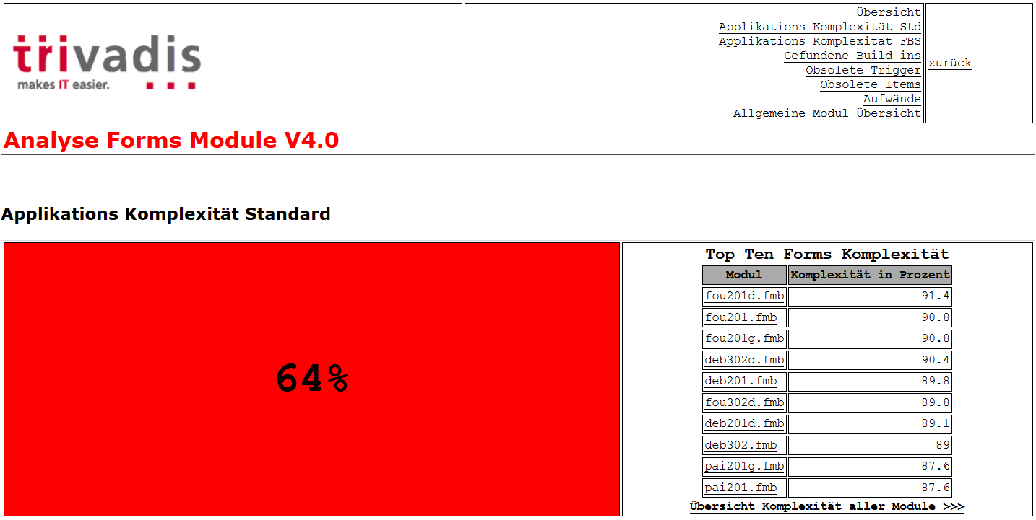
Figure 1 Application Complexity
The entire application has a high complexity of 63%. The ten Forms modules with the highest complexity range between 91.8% and 88%.

Application Complexity Distribution
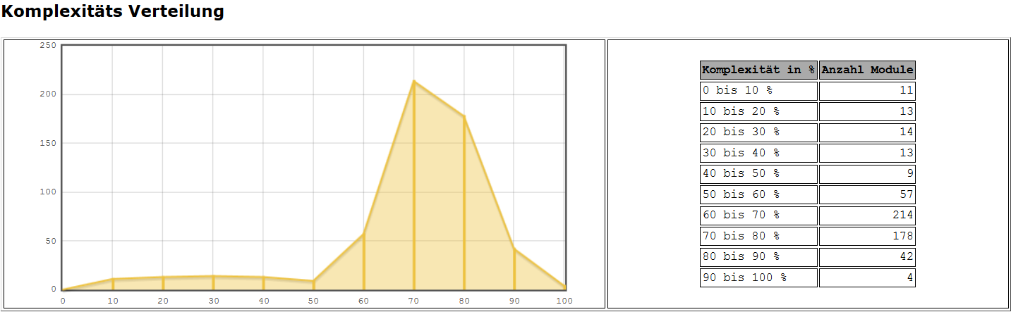
Figure 2 Application Complexity Distribution
442 Forms modules (FMB, PLL, MMB) have a high complexity.

Application Complexity Code Documentation
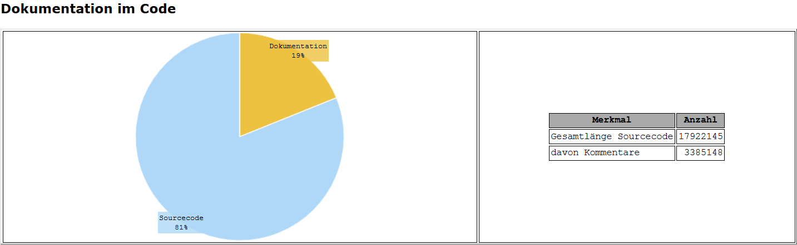
Figure 3 Application Complexity Code Documentation
There is a high amount of source code in the application. Nearly every Forms standard functionality is abstracted through own PL/SQL code. The percentage of source code documentation is low for this amount of code.

Application Complexity Database Access
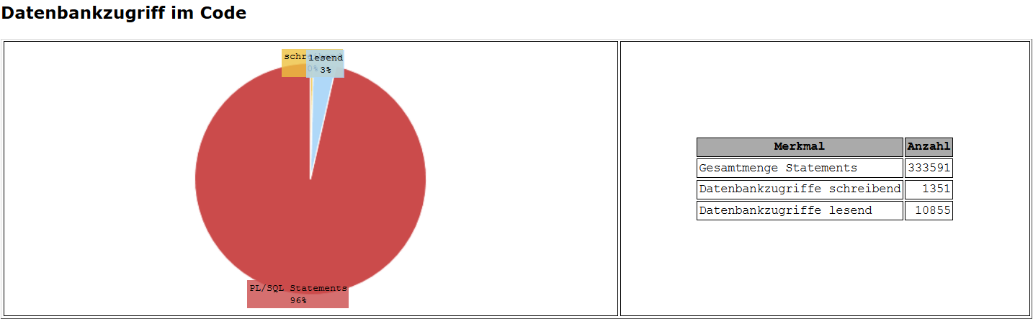
Figure 4 Overall Application Complexity
A statement is a PL/SQL statement terminated with a semicolon.
Database access is split into reading (select) and writing (insert, update, delete) statements. The number of reading statements is low also the number of writing statements.

Application Complexity Data Blocks
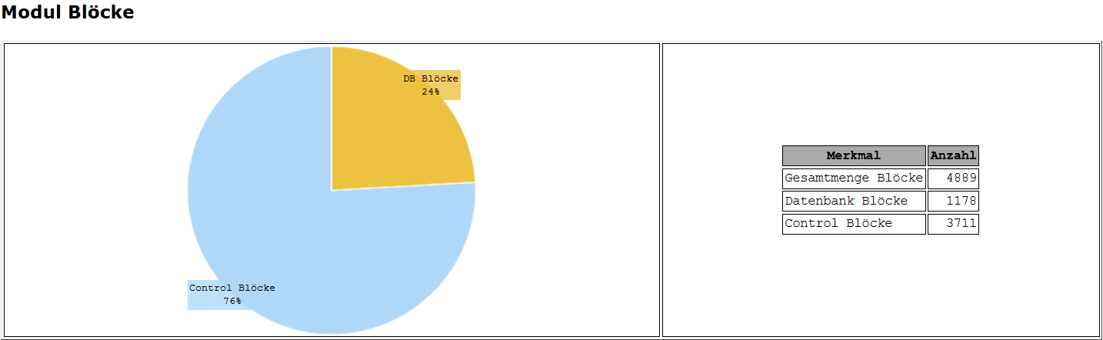
Figure 5 Application Data Blocks
The total number of data blocks is high. There are more control blocks than database data blocks.

Application Complexity Criteria and Weighting
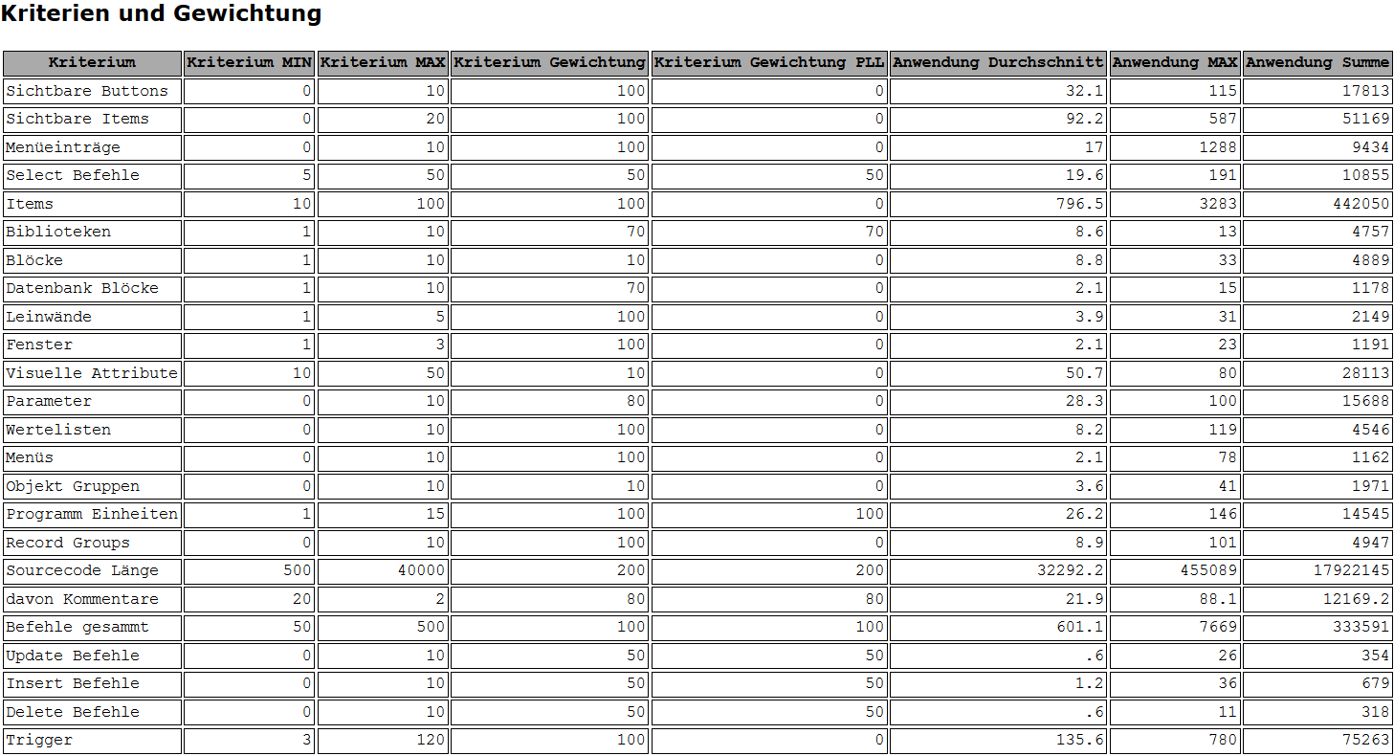
Figure 6 Application Complexity Criteria and Weighting
The definition of the criteria is carried out as described in 5.1. Additionally statistical values related to each criterion will be provided.
- Application Average: e.g. each module contains 8.8 Data Blocks
- Application MAX: e.g. there is one module containing 33 Data Blocks
- Application Sum: e.g. there are 4889 Data Blocks in the entire application

Forms Upgrade Issues
Upgrade issues are classified depending on the needed development effort to solve the issue. The analysis report differentiates between 4 classes.
Class | Description
A | The issue can be solved automatically using an existing script.
B | The script solving the issue needs to be developed once and can be used for all occurrences of the issue.
C | The solution for these issues needs to be developed in the Forms Builder. The possibilities to use an automated script are limited.
D | These issues must be resolved manually for each occurrence.

Obsolete Built-Ins
The following table contains important obsolete built-ins found in the application. For a complete list check the Analysis Report.
Class | Built-In | Solution
C | OLE2 | Manual Correction CLIENT_OLE2
A,C | HOST | Automatic correction with CLIENT_UTIL.HOST when running on the client. Must be checked.
D | ORA_FFI | Manual correction
C | RUN_PRODUCT  DESNAME | Manual correction with RUN_REPORT_OBJECT  Manual correction of DESNAME values
A,C | TEXT_IO | Automatic correction with CLIENT_TEXT_IO when running on the client
A | WIN_API* | Automatic Correction with CLIENT_UTIL* possible. Must be checked.

Obsolete Triggers
No obsolete triggers found.

Triggers with Restricted Usage
No obsolete triggers found.

Obsolete Item Types
The following Item Types are no longer supported by Forms 11g.
Item Type | Description
Chart Item | No upgrade path. Oracle provides JavaBeans for the integration of charts.
VBX | Was applicable to 16-bit Windows platforms only. No upgrade path or replacement functionality.
OLE Container | Was applicable to Windows platforms only. Programmatic OLE interaction is supported with external OLE servers on the middle tier.
OCX/ActiveX Controls | Was applicable to Windows platforms only. JavaBean support provides similar functionality.
Sound | No migration path. JavaBeans can be used to provide equivalent functionality.
Two items of type OLE Container were found in the Forms Module POSTIT.FMB.

Analysis Report
Take the following notes to the results in the Analysis Report:
- Most of the issues are of class A which can be resolved automatically through scripts.
- The number of found issues is greater than the real number of issues. Sometimes the searched strings are part of a name. Those places are also listed and counted.
- In most cases there are only a few central files involved.

Removed Components

Oracle Terminal
The resource files used by Web-deployed forms are text based and can be edited using a conventional text editor. As a result, Oracle Terminal is no longer required for the product.

Effort Estimation

Correction of Upgrade Issues
The estimated results of the automated technical analysis of the Forms and Reports Modules are listed in the table below. The information in the column "Effort" specifies the number of days needed for the technical migration (1:1) of the Forms and Reports Modules. It does not include testing or other project related effort. The estimation effort calculation is based on the following conditions:
- Trivadis consultants perform the migration of the Forms and Reports modules using the Trivadis migration environment and migration scripts.
- The migration environment uses Forms API Master to change the Forms and Reports.
Issue | Class | Solution Approach | Effort
ORA_FFI | D | These issues must be resolved manually for each occurrence. | 6
Reports Integration | C | The solution for these issues needs to be developed in the Forms Builder. The possibilities to use an automated script are limited. | 2
TEXT_IO | A,C | The script solving the issue needs to be developed once and can be used for all occurrences of the issue. | 1
OLE2 | C,D | The solution for these issues needs to be developed in the Forms Builder. The possibilities to use an automated script are limited. | 3
HOST | A,C | The script solving the issue needs to be developed once and can be used for all occurrences of the issue. | 1
Diverse Items | A | The issue can be solved automatically using an existing script. | 2
Reports Modules | A,C | The script solving the issue needs to be developed once and can be used for all occurrences of the issue. | 3
 |  |  | 18

Infrastructure

Intranet Architecture
The intranet architecture illustrated below is a simple example for a Forms application with up to 100 users. There is one central database server running the database instance and one application server running the Forms and Reports Server instance.
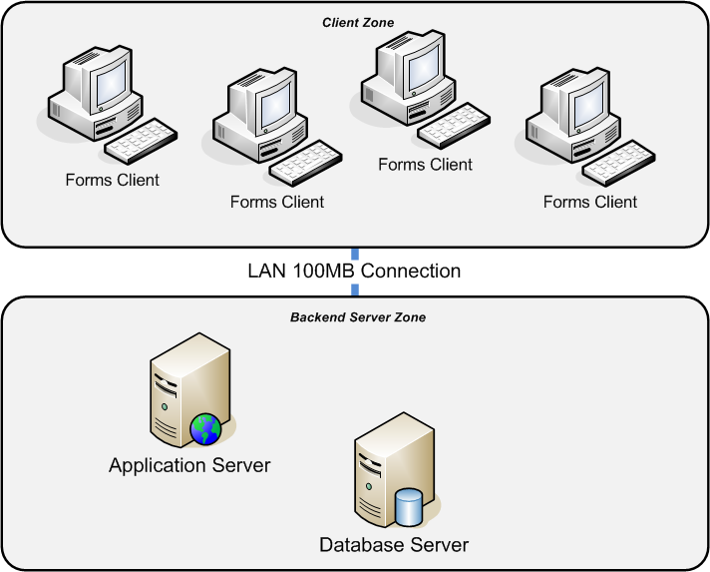
Figure 7 Simple Intranet Architecture
- Forms Client: Windows Operating System
- Application Server: Forms and Reports Server 11g
- Database Server: Oracle Database 11gR2
- LAN Connection: 100MB

Additional servers are needed
- If more concurrent users are working with the application
- If the application is business critical and must to be available

High Availability
If the application is business critical and must to be available 24 hours a day an additional application server is needed. The application servers must not be clustered. A solution with two active servers is recommended, but an active-passive scenario is also possible.

Forms Server Architecture
The figure below illustrates the technical components of a Forms 11g server installation and their distribution.
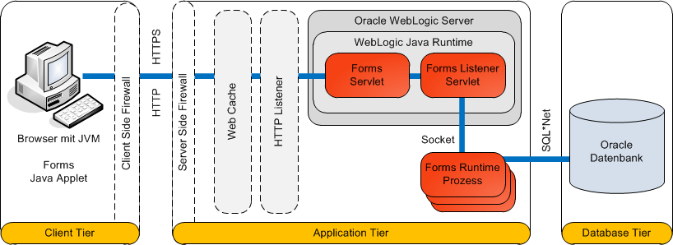
Figure 8 Forms 11g Architecture and technical Components
- Client Tier: The client computer is using a browser to start the Forms application. The browser needs a Java Runtime Environment to start the Forms Java Applet. The Forms client establishes a permanent connection to the Forms Listener Servlet on the application server.
- Application Tier: The Forms Runtime Process (FMX) is executed on the application server. The Forms Runtime Process establishes a permanent connection to the Oracle Database.
- Database Tier: The Oracle Database stores the data maintained through the application.

Server Configuration
The following server hardware configuration is recommended for a Forms and Reports 11g production system.
Component | Value
Operating System | Windows Server 2008 Release 2 64bit
CPU and Cores | CPU 1, Cores 4, above 2Ghz
Memory | 16 GB
Hard-Disk Capacity | At least 40GB

Memory Estimation
The Forms Runtime Process needs physical memory on the application server to run properly. Depending on the high complexity of the GEFI Forms modules each session will need approximately 50-100MB memory.
- The average value is 75MB for each Forms session
- The needed amount of memory is a linear calculation
- 100 Forms sessions will allocate 7500MB memory
Component | Physical Memory GB
Windows Operating System 64bit | 4.0
Forms Server | 2.0
Forms Sessions | 7.5
Reports Server | 2.5
 | 16.0

Network Bandwidth
Since the Forms application establishes permanent connections from the client to the application server the network bandwidth should be a 100MB LAN connection. This will work fine.
External clients connecting to the application with lower network bandwidth are often facing network interruptions. The client must connect to the application again. The last transaction is lost.
A possible solution for those external clients can be implemented using a Citrix client. The external computer connects to the Citrix client first to start the Forms application.

Licensing
The following statements towards Oracle licensing options are based on the workshop results and the recommended infrastructure configuration. The licensing conditions reflect the standard customer infrastructure.
The Oracle licenses need to be bought by the customer. The customer must accept the Oracle License and Service conditions.

Contact
Please request an explicit license calculation for an explicit customer infrastructure.
Trivadis AG
Andreas Stärkel
Senior Partner Manager Sales
Stuttgart, Germany
Phone +49 711 90 36 32 35
E-Mail Andreas.Staerkel@trivadis.com

Development Environment Licenses
The development environments are licensed by the Internet Developer Suite. As long as only these developers are developing and testing, the following component products are included:
- Designer
- Forms Developer
- Reports Developer
- Business Components for Java
- Discoverer Administration Edition
- SQL*Plus
- 1 license of Discoverer Desktop Edition restricted to the Named User of iDS.
Restricted Use:
- iAS Enterprise Edition and its options restricted to testing and debugging the deployment of application developed with iDS
- Oracle Database Enterprise Edition and its options

Test Environment Licenses
For real life tests, the test environment needs a normal production license.

Production Environment Licenses
For production environments you can choose between two license metrics:
- Named User Plus (NUP) License
- Processor License, based on the number of CPUs and Cores
NUP or Processor Licenses are the only possible license metrics. A license metric for concurrent users is not available.

Named User Plus License Conditions
- Based on the number of real life users or named persons
- You need to know the exact number of persons or real life users
- You will need at least 2 * 10 NUP = 20 NUP for the Application Server product
- The minimum license, when licensing with NUP metric. You always need to license the amount which is bigger: either real life persons or amount of minimum licenses

Processor License Conditions
- Based on the number of CPUs and Cores
- For systems with 1*4 Intel-Cores = 4 Cores * 0,5 (Intel Multicore-Factor) = 2 Oracle Processor Licenses are calculated

Example Calculation

Application Server Production Environment
The following example is based on 100 real life users. The license metric is Named User Plus. The licenses are full use-licenses.
Quantity | Description | Net Price CHF
100 Users | Application Server - Forms and Reports | 37,995.00
100 Users | Software Updates & Product Support first year | 8,364.85
These are deducted prices with a 15% discount.
With this amount of users the customer can use servers in sum with up to 20 Intel-Cores.

Development
The following example calculates the cost for one developer.
Quantity | Description | Net Price CHF
1 User | Internet Developer Suite | 4,794.00
1 User | Software Updates & Product Support first year | 1,054.66
These are deducted prices with a 15% discount.

Additional Notes
- If the customer wants to do development tasks by its own, then all people doing development tasks need to have an Internet Developer Suite license. You can easily multiply the amount.
- Since OFISA is part of the Oracle Partner Network all the required licenses for developing and testing of an application which is sold to several customers can be used as a member of the OPN without additional license costs.
- For virtualized systems, the same rules apply like in the database area. You need to be careful with VMWare ESX-Cluster. Only technologies classified as “Hard-Partitioning” can limit the amount of required licenses.
How does it affect the license cost, if the customer has only 50 real life users or is using a machine with only two cores?
- The minimum license would be 2 Cores * 0,5 (for Intel Multicore) * 10 = 10 NUP
- But the real life number is 50, so they have to license 50 NUP or alternate 1 processor

Next Steps
The Analysis Report is a good starting point for the migration project. You will find all the modules with upgrade issues. A detailed technical and functional analysis is needed to create solutions for the issues.
Trivadis can perform the technical migration (1:1) of the Forms and Reports Modules for you using the Trivadis migration environment and migration scripts. The migration environment uses Forms API Master to change the Forms and Reports.
Trivadis can also assist you to create the new development environment for the new Forms and Reports versions. A special training course O-WLS-FR is available for Forms and Reports administrators.
An exact license calculation is needed for your customers using the new Forms and Reports version. Do not hesitate to contact us for this job.

Addendum

Short Terms
Within this document the following short terms have been used:
Short Term | Description
FBS | Feature Breakdown Structure
NUP | Named User Plus License
iAS | Oracle Internet Application Server
iDS | Oracle Internet Developer Suite

Oracle Documents and References
- Oracle® Fusion Middleware Installation Guide for Oracle Forms and Reports 11g Release 2 (11.1.2)
http://docs.oracle.com/cd/E48391_01/doc.11120/e23960/toc.htm
- Oracle® Fusion Middleware System Requirements and Specifications for Oracle Forms and Reports 11g Release 2 (11.1.2)
http://docs.oracle.com/html/E25460_01/r2_fr_requirements.htm
- Oracle® Fusion Middleware Forms and Reports Documentation Library 11g Release 2 (11.1.2.2.0)
http://docs.oracle.com/cd/E48391_01/index.htm

